MODEL YL600P
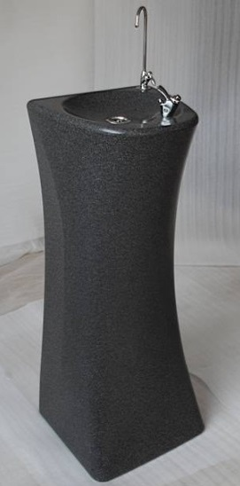
Water Supply: Mains water supply
Dimensions (mm): 370 width x 430 depth x 1060 height (boxed 420mm width x 440 depth x 1100 height)
Weight: 30kgs
Colour: Grey Plastic
Power Supply: 220/240 volt, 50hz, 200 watt, 1PH, 1.5 amps
Cooling system: Compressor, R134a refrigerant

DESCRIPTION:
Modern stylish, floor standing refrigerated water cooler
With holding capacity 4.2 litre water storage tank
Ideal for Industrial use
Will produce approximately 20 litres of cold water per hour
This water cooler is fitted with a bubbler and glass filler
A twelve month warranty

All specifications parameters, dimensions, and performances subject to change without notice

